**CURRICULUM VITAE**

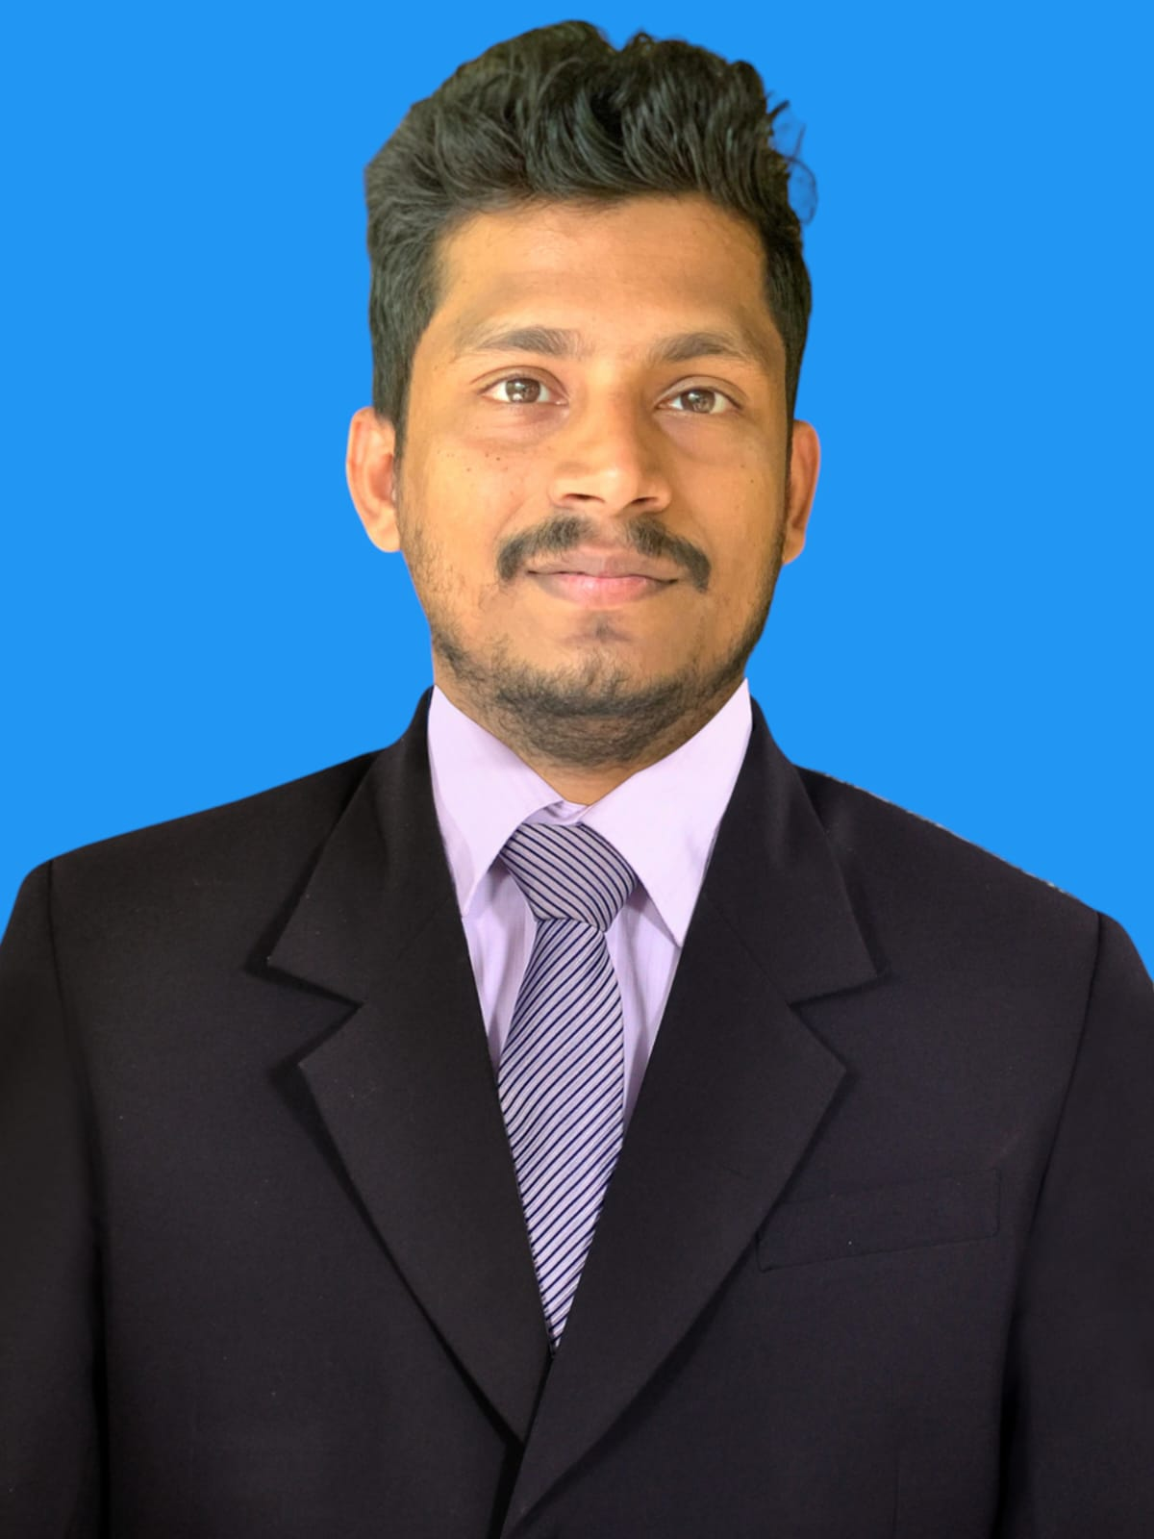

**PERSONAL DETAILS - Mohammed Sulaim M  
JOB DESCRIPTION- Mobile Technician**

Residential Address: Malayantavida House, Kollavalloor, Kannaur, Kerala.

Date of Birth: 30 November 199 3

Nationality: Indian

Website: sulaim.info

**CAREER OBJECTIVE**

Helps out with servicing mobile phones and enjoys troubleshooting circuit boards, making repairs, software installation and performing main role in team.

**EDUCATION QUALIFICATION**

June 2009 – March 2011 +2 Computer Science from VHSE board Kerala.

March 2009 Completed SSLC from Kerala Secondary Educational Board.

**TECHNICAL QUALIFICATION**

12-09-2011 to 22-02-2012 Completed Mobile Phone Technician course at Mobile Tech-Institute of Mobile & Electronics Technology, Kuthuparamba, Kerala, India

November 2010 Completed Job training in Photoshop-CEDC-Thalassery, Kerala, India

**WORK EXPERIENCE**

|  |  |
| --- | --- |
| 20-Sept-2014 to Current date | **Jas Garments & Electronics- Abu Dhabi-UAE**  Responsibilities:   * Mobile Software Installation and Updating. * Servicing any brand of mobiles including Apple. * Computer hardware troubleshooting & Software installation. * Also handle sales, |
| 01-August-2013 to 12-july-2014 | **CellKing Service Center-Kasaragod-Kerala-India**  Responsibilities:   * Mobile phone Servicing & Sales. * Software installation and troubleshooting * Computer hardware. |
| 28-November-2012 to 31-July-2013 | **Indian Metro Training -Kasaragod-Kerala-India**  Responsibilities:   * Mobile phone Servicing. * Computer Hardware * Mobile & Computer software installation |

**OTHER SKILLS**

**Mobile related Skills:**

* Receive, diagnose, repair, refurbish, upgrade and or dispose of all Cellular mobile telecommunications handsets.
* Prepare an estimation cost of repair and give a feedback to the receptionist prior to communicate with the customer only if necessary.
* Carry out all repair procedures in line with Quality and Environmental guidelines.

**Computer Skills:**

* Microsoft Office applications (Word, Excel, Office, PowerPoint).
* Basic Knowledge in Adobe Photoshop.
* Servicing and troubleshooting Microsoft Windows.
* Desktop and Laptop Servicing.
* basic knowledge of coding.

**Language Skills:**

* Malayalam, English and Hindi.

**PERSONAL COMPETENCIES**

* Ability to work in a fast-paced environment to set deadlines.
* Highly organized with a creative flair for team work.
* Enthusiastic self-starter who contributes well to the team.

**INTERESTS AND ACTIVITIES**

* E-learning, Internet surfing, Football, Music, graphic design.

**PERSONAL DETAILS**

**Email ID:** [sulaimsulu@gmail.com](mailto:sulaimsulu@gmail.com)

**Website** :www.sulaim.info  
**Passport Number**: K1524358  
  
**Present Address:**  
Jas Garments & Electronics- Abu Dhabi-UAE  
  
**Permanent Address:**  
Malayantavida House, Kollavalloor, Kannaur, Kerala,India.

**DECLARATION**

I hereby declare that all data furnished here are true to the best of my knowledge.

**Mohammed Sulaim M**  
Dubai-UAE